Convert PDF files to XPS format

XPS, as a new document format released by Windows vista, is an alternative to represent document in electronic format beside PDF by adobe. XPS not only owns functions for document of viewing, printing and archiving, but also be applied as a specific file format for storing all document types.
However, there are some trouble for users .For some reasons, people who prefer XPS want to open document in XPS format, while the document is represented in PDF and they have to install XPS viewer, and vice versa. As we know, viewing XPS can only be achieved by XPS viewer, which can open documents automatically in an Internet Explorer window. Thus users have to install it while using XPS format to check document, and it takes time. The following shows the way that how we solve these kinds of problems quickly by conversion in our latest version-Spire.PDF 2.8.

Procedure of Converting PDF to XPS
Step 1.Create a new project
- Please create a new project in Visual Studio, and choose Console application.
- Set the Target framework to be .NET Framework 2.0 in properties
Step2.Add reference
- Add Spire.pdf as a reference
Add using at the top of the method .See below:

C# Code:
//pdf file
String file = @"..\..\..\..\..\..\Data\Sample4.pdf";

//open pdf document
PdfDocument doc = new PdfDocument(file);

//convert to xps file.
doc.SaveToFile("Sample4.xps", FileFormat.XPS);
doc.Close();

Step3. Convert PDF to XPS

C# Code:
using System;
using System.Collections.Generic;
using System.Linq;
using System.Text;
using Spire.Pdf;

namespace Demo_PdftoXps1
{
class Program
{
static void Main(string[] args)
{
//pdf file
String file = @"D:\vstest\Form.pdf";

//open pdf document
PdfDocument doc = new PdfDocument(file);

//convert to xps file.
doc.SaveToFile("Sample4.xps", FileFormat.XPS);
doc.Close();
}
}
}
Preview
- Image before converting :
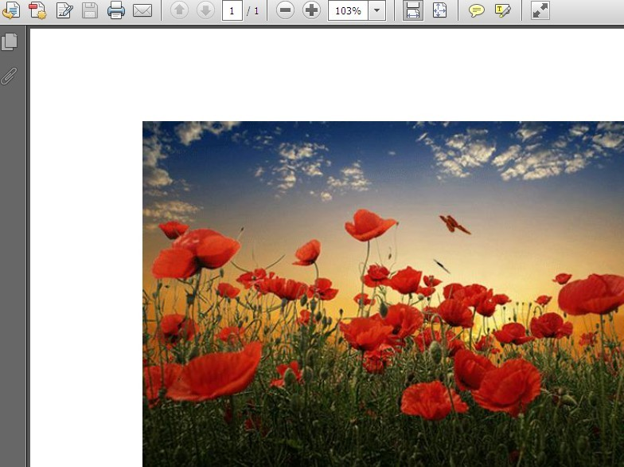

- Image after converting :

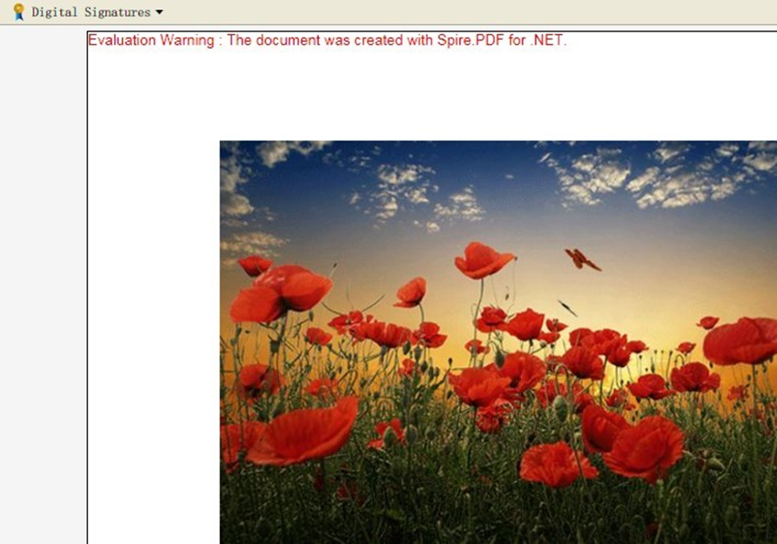
Welcome to experience Spire PDF.2.8,please visit:
http://www.e-iceblue.com/News/spirepdfsupports-pdf-to-xps-and-image-now.html

