My computer is on two languages, English and Thai. Somtime I forgot to change language into English it causes hanging up of Octave GUI on the Command Window but the other windows, editor, help, variable editor are working fine.

The pictures below are the steps lead to the no responsd of Command Window.

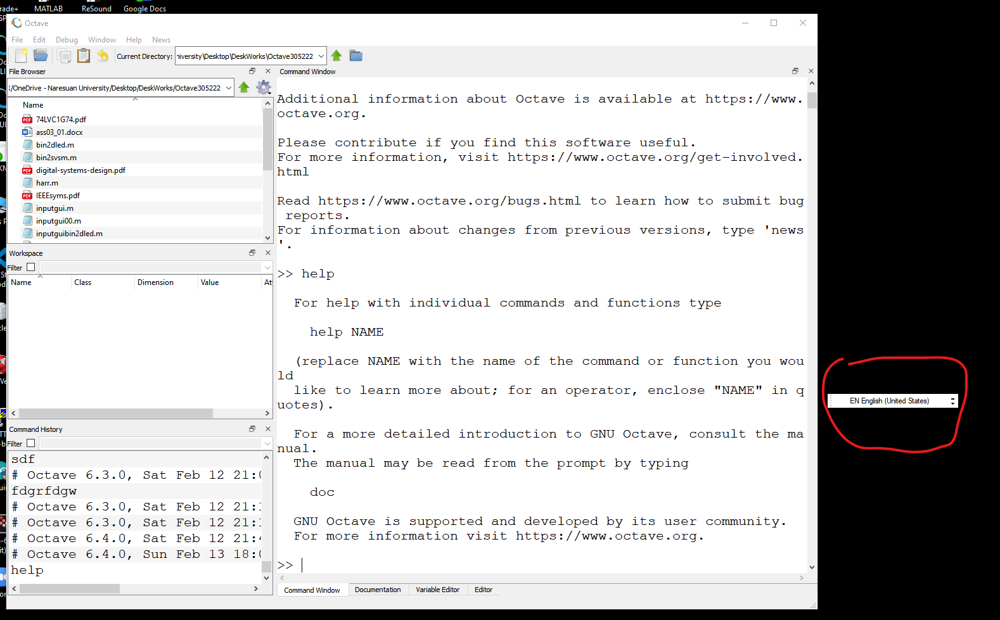

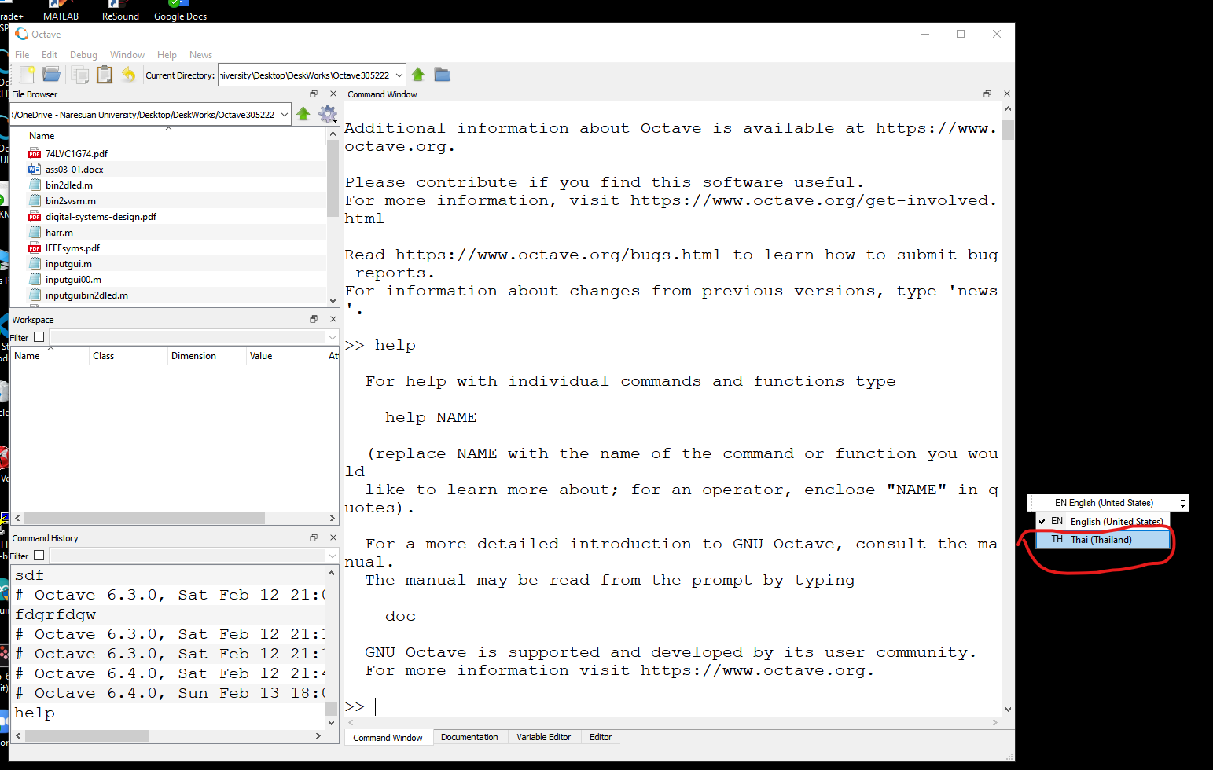

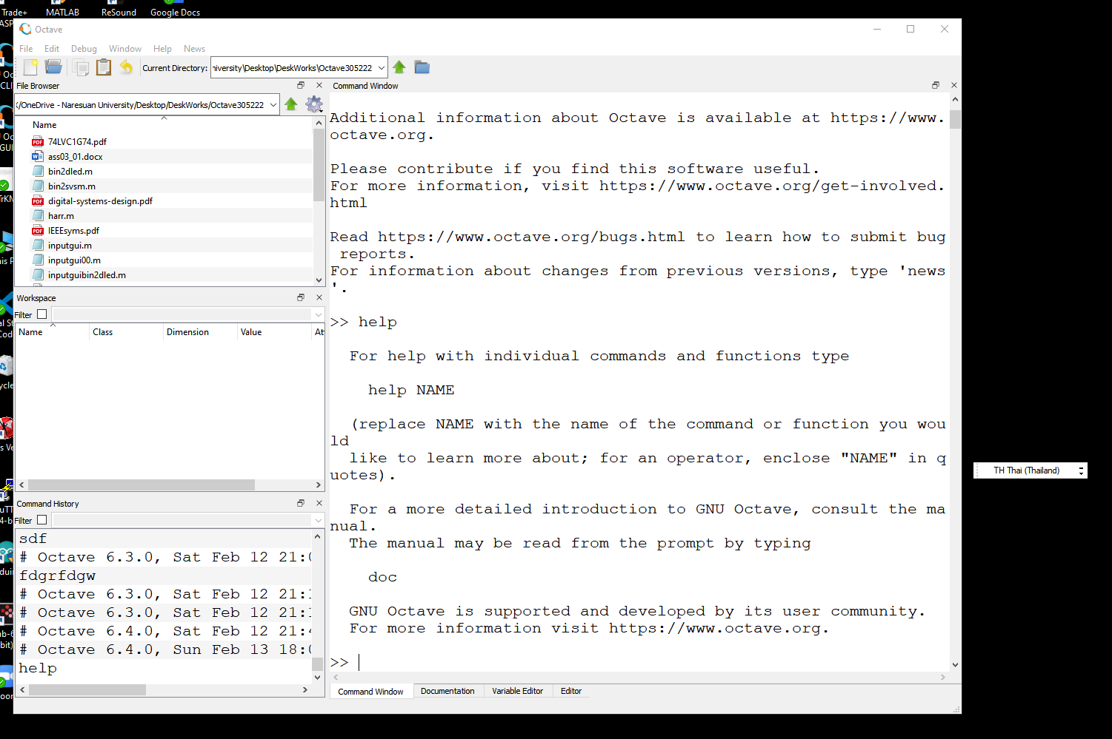
Typing something in Thai here
After (must) typing the keyboard with the TH Thai (Thailand) in Command Window, the result is not thing in the command window, then change the Window display Language back to EN English (United States). After that the Command Window will not respond any keyboard activities.
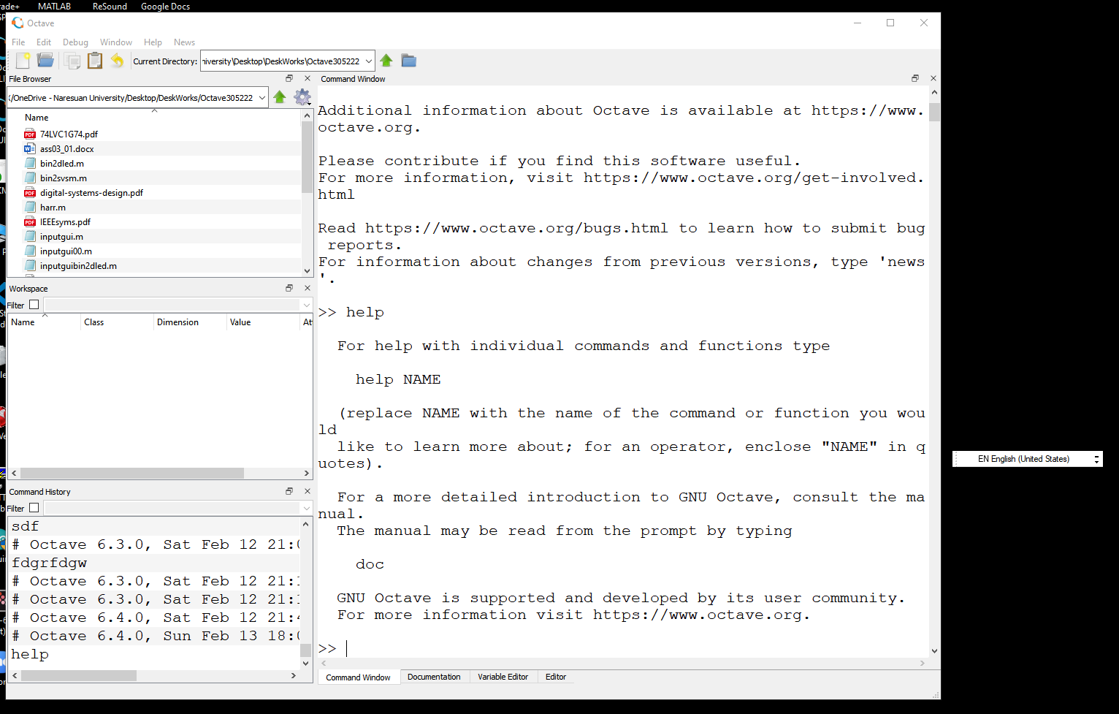
Typing something in English here

The Clear Window Menu is not working after those activities.

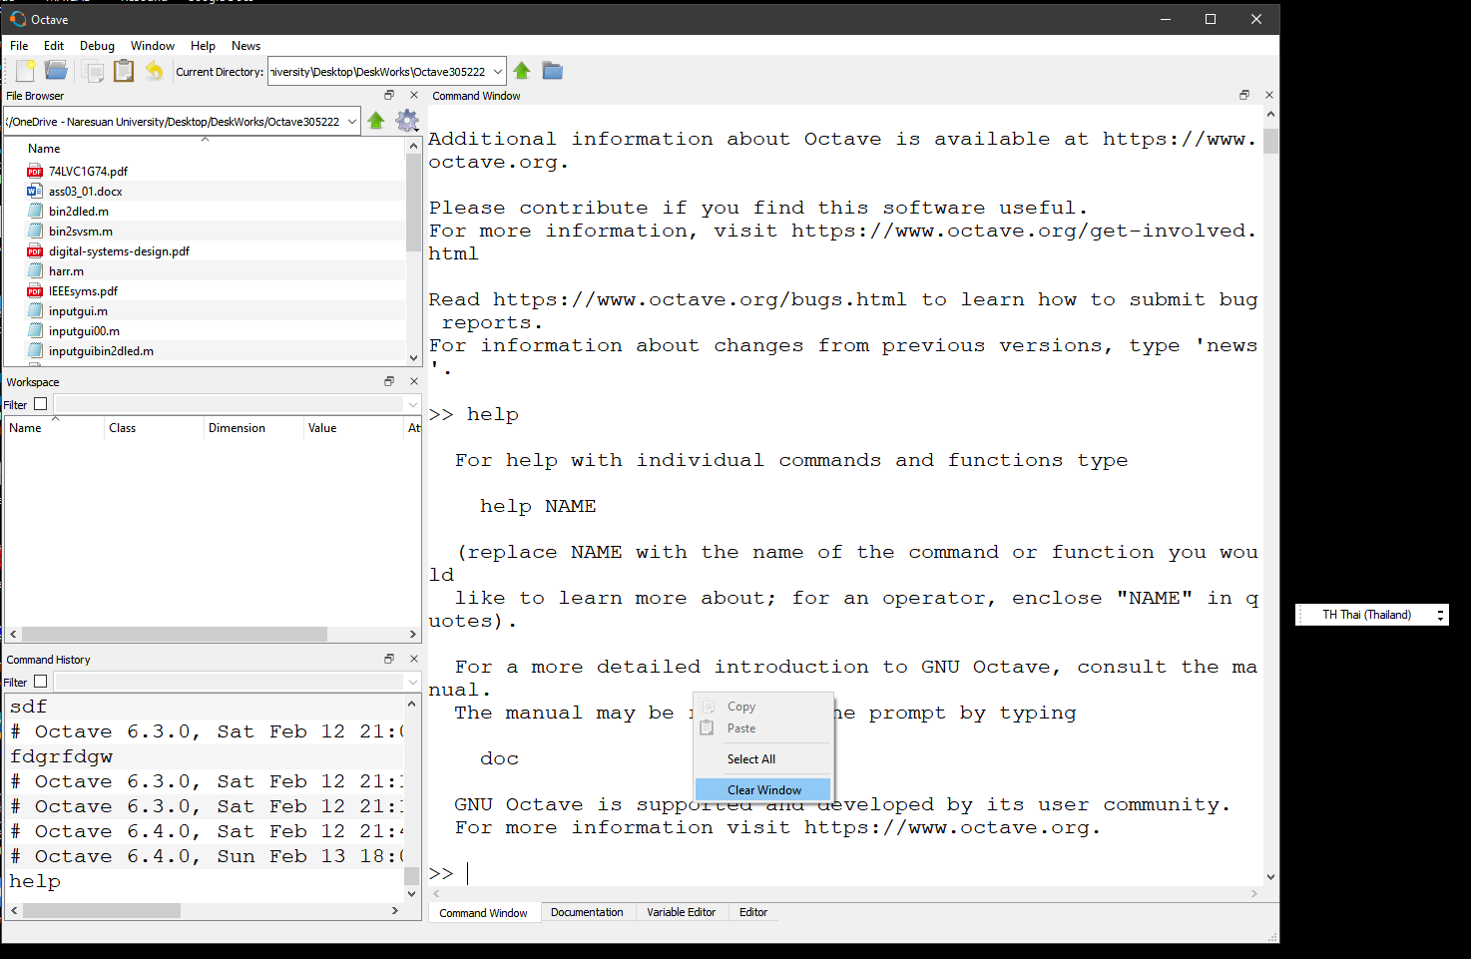

Cannot do any typing or reset the command window. It hangs up all time.

