Plot in octave bug
Plot3(fft(set of data)) normal and complex numbers
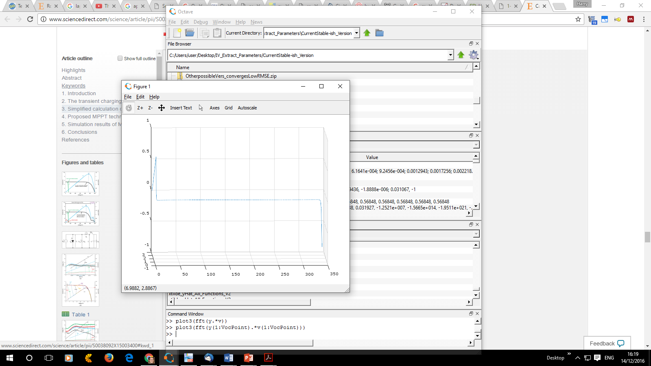
Rotate more so only 2 axes are seen
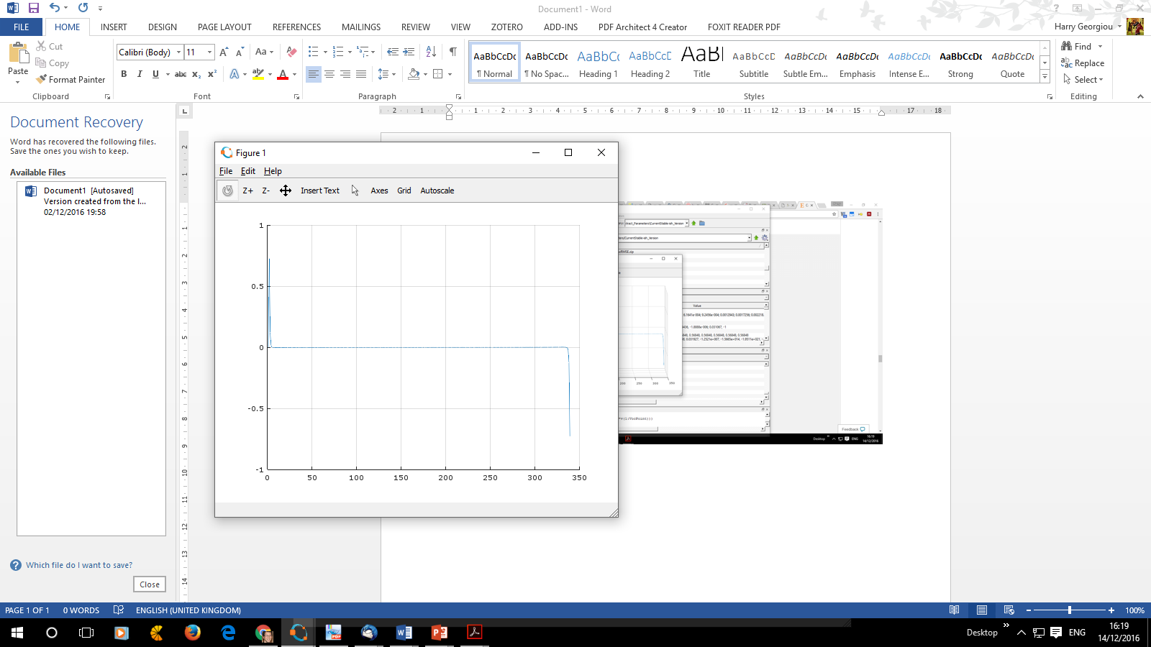
Want to zoom in to take a better look
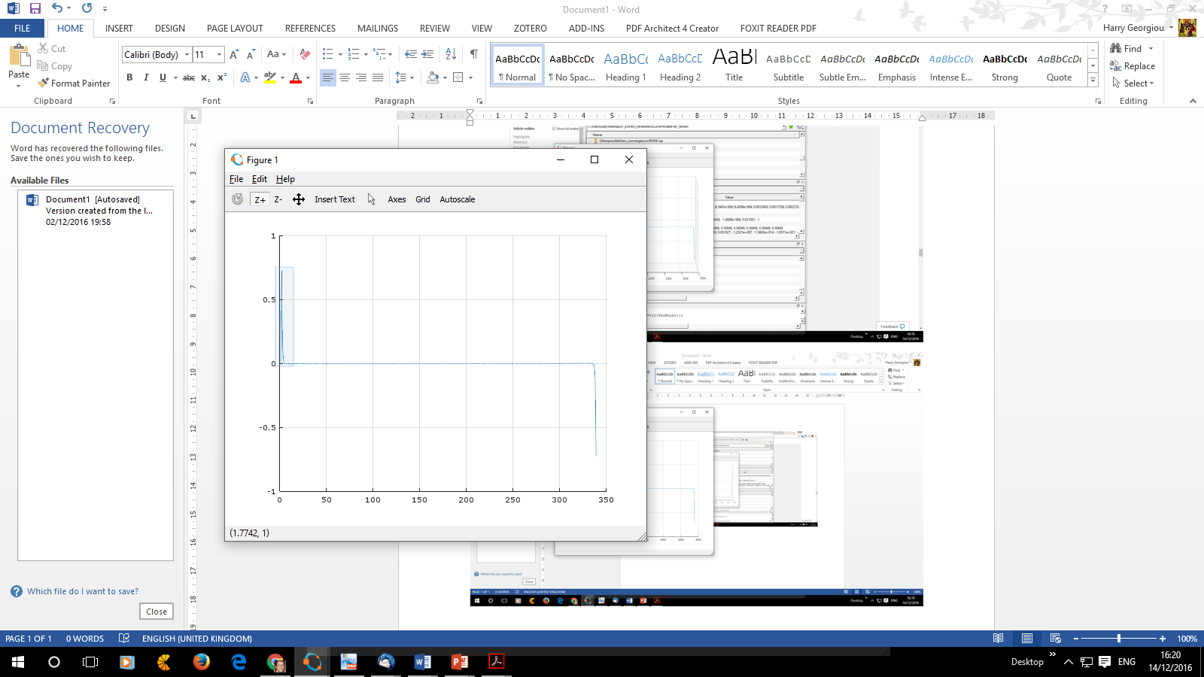

Result
Hmm…. Not quite the right result.
This also happens when one zooms in many times and the axes lose themselves too
